Smart waste management

system

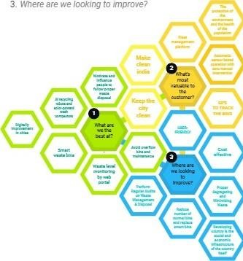Team ID :

PNT2022TMID06442

STEP 1

Problem Solving Cards

-Basic question

*Problem Statement

1 _ Whats most valuable to the customer?

1. What are we the best at?
2. Where are we looking to improve?

STEP 2

Framing Statements

•nart waste mam%nEnt system



Previously there were numerous initiatives on waste management and educating people to dispose waste properly, and as they failed to achieve significant results, we have figured out the scopes that could be develop. To solve this problem, we have designed a process that ensures proper disposal and efficient waste collection. The procedures we designed involves creative initiative that will inspire people to dump in designated area or bins, and innovative method by using Decreasing Time algorithm or DTA for monitoring garbage generation and collection of the garbage's.

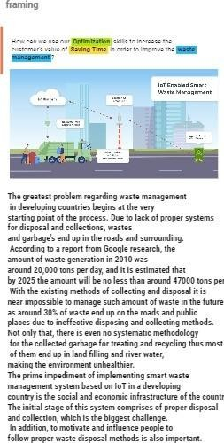

—try

da

y.

STEP 3

Ideas

Problem Solution

